EXPERIMENT NO. 8: MEDCARE HOSPITAL ONLINE APPOINTMENT BOOKING SYSTEM
AIM:
To develop a healthcare portal for MedCare Hospital enabling patients to search doctors by specialty/location, schedule appointment slots, submit online pre-consultation check-in symptoms, and allow hospital admins to manage doctor rosters and patient stats.
PSEUDOCODE (IN 6 SIMPLE POINTS):
Step 1: Initialize medical database with departments (Cardiology, Orthopedics, Pediatrics), doctors, and available consultation hours.
Step 2: Provide search interface allowing patients to filter doctors by medical specialty, experience, and branch location.
Step 3: Display doctor profile cards showing qualification, consultation fee, hospital room, and real-time appointment slots.
Step 4: Allow patient to select preferred consultation time and fill out an online digital check-in form with symptoms and medical history.
Step 5: Generate an electronic appointment pass featuring patient token number, appointment time, and doctor cabin information.
Step 6: Equip hospital admin with controls to add/update doctor rosters, monitor daily patient statistics, and review department ratings.
SOURCE CODE:
<!DOCTYPE html>
<html lang="en">
<head>
<meta charset="UTF-8">
<title>MedCare Hospital - Doctor Appointment Booking</title>
<style>
body { font-family: 'Segoe UI', Arial, sans-serif; margin: 0; background: #f0fdf4; color: #1e293b; }
header { background: #059669; color: white; padding: 20px 40px; display: flex; justify-content: space-between; align-items: center; }
.main { max-width: 950px; margin: 25px auto; background: white; padding: 25px; border-radius: 8px; box-shadow: 0 4px 12px rgba(5,150,105,0.1); }
.filter-row { display: grid; grid-template-columns: repeat(3, 1fr); gap: 15px; margin-bottom: 20px; }
select, input, textarea, button { width: 100%; padding: 10px; border: 1px solid #cbd5e1; border-radius: 6px; box-sizing: border-box; }
button { background: #059669; color: white; border: none; font-weight: bold; cursor: pointer; }
button:hover { background: #047857; }
.doc-card { border: 1px solid #e2e8f0; border-radius: 8px; padding: 18px; margin-bottom: 15px; display: flex; justify-content: space-between; align-items: center; }
.token-card { background: #ecfdf5; border: 2px dashed #059669; padding: 20px; border-radius: 8px; margin-top: 20px; }
</style>
</head>
<body>
<header>
<h2>MedCare Multispeciality Hospital</h2>
<span>Patient Appointment Portal</span>
</header>
<div class="main">
<h3>Find a Doctor by Specialty & Branch</h3>
<div class="filter-row">
<select id="deptFilter" onchange="filterDoctors()">
<option value="All">All Specialties</option>
<option value="Cardiology">Cardiology</option>
<option value="Pediatrics">Pediatrics</option>
<option value="Neurology">Neurology</option>
</select>
<input type="text" id="locFilter" placeholder="Search Location (e.g. City Central)">
<input type="date" id="aptDate">
</div>
<div id="doctorList">
<div class="doc-card" data-dept="Cardiology">
<div>
<h4 style="margin:0; color:#065f46;">Dr. Arvind Menon, MD, DM (Cardiology)</h4>
<p style="margin:4px 0; color:#64748b;">Senior Interventional Cardiologist | 15 Yrs Exp</p>
<small>Consultation Fee: Rs. 800 | OPD Cabin: 204</small>
</div>
<button onclick="openCheckin('Dr. Arvind Menon', 'Cardiology', 800)" style="width: auto; padding: 8px 18px;">Book Slot</button>
</div>
<div class="doc-card" data-dept="Pediatrics">
<div>
<h4 style="margin:0; color:#065f46;">Dr. Shalini Rao, MD (Pediatrics)</h4>
<p style="margin:4px 0; color:#64748b;">Child Care & Vaccination Specialist | 10 Yrs Exp</p>
<small>Consultation Fee: Rs. 600 | OPD Cabin: 108</small>
</div>
<button onclick="openCheckin('Dr. Shalini Rao', 'Pediatrics', 600)" style="width: auto; padding: 8px 18px;">Book Slot</button>
</div>
</div>
<!-- Pre-Consultation Check-In Form -->
<div id="checkinModal" style="display:none; margin-top:25px; border-top:2px solid #e2e8f0; padding-top:20px;">
<h3 id="targetDoctorTitle"></h3>
<h4>Online Pre-Consultation Check-In Form</h4>
<div style="display:grid; grid-template-columns: 1fr 1fr; gap: 15px;">
<input type="text" id="patientName" placeholder="Patient Full Name" required>
<input type="number" id="patientAge" placeholder="Age" required>
</div>
<textarea id="symptoms" rows="3" placeholder="Describe symptoms or reasons for visit..." style="margin-top:10px;"></textarea>
<button onclick="generateAppointmentPass()" style="margin-top:10px; width: 220px;">Confirm & Get Token</button>
</div>
<div id="tokenOutput"></div>
</div>
<script>
let selectedDoc = {};
function openCheckin(docName, dept, fee) {
selectedDoc = { docName, dept, fee };
document.getElementById('checkinModal').style.display = 'block';
document.getElementById('targetDoctorTitle').innerText = 'Appointment with ' + docName + ' (' + dept + ')';
}
function filterDoctors() {
let dept = document.getElementById('deptFilter').value;
let cards = document.querySelectorAll('.doc-card');
cards.forEach(card => {
if(dept === 'All' || card.getAttribute('data-dept') === dept) {
card.style.display = 'flex';
} else {
card.style.display = 'none';
}
});
}
function generateAppointmentPass() {
let name = document.getElementById('patientName').value.trim();
let age = document.getElementById('patientAge').value.trim();
let symp = document.getElementById('symptoms').value.trim();
let date = document.getElementById('aptDate').value;
if(!name || !age || !date) return alert('Please enter patient details and appointment date');
let token = 'MED-' + Math.floor(100 + Math.random() * 900);
document.getElementById('tokenOutput').innerHTML = `
<div class="token-card">
<h3 style="color:#059669; margin-top:0;">Hospital Appointment Token Confirmed</h3>
<p><b>Token Number:</b> <span style="font-size:20px; font-weight:bold; color:#047857;">${token}</span></p>
<p><b>Patient:</b> ${name} (${age} yrs) | <b>Symptoms:</b> ${symp || 'General Checkup'}</p>
<p><b>Doctor:</b> ${selectedDoc.docName} | <b>Date:</b> ${date}</p>
<p><b>Consultation Fee:</b> Rs. ${selectedDoc.fee} (Payable at counter or online)</p>
<small>Please arrive 15 minutes before the scheduled OPD slot.</small>
</div>`;
}
</script>
</body>
</html>
Output:
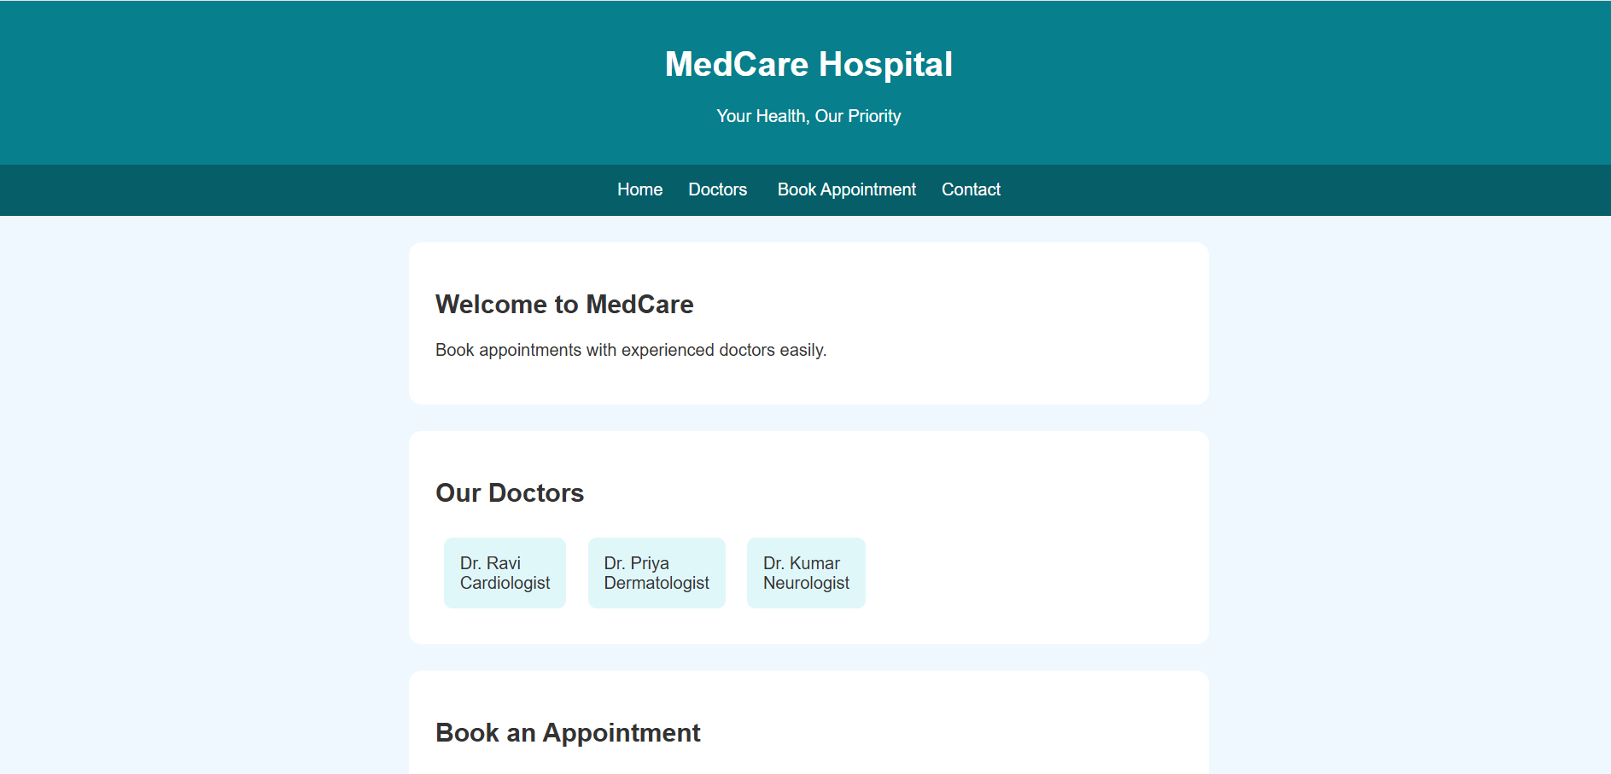
RESULT:
Thus, the MedCare Hospital online appointment booking system was successfully developed and verified, enabling department filtering, slot reservation, digital symptom check-in, and instant token generation.

